1. Introduction
Diabetes has become one of the most common long-term health conditions, and for many people, managing it goes far beyond taking medication. What they eat every day has a direct impact on their blood sugar levels, overall well-being, and risk of future complications. Yet most people especially diabetic and pre-diabetic individuals struggle to understand how their daily meals actually affect their health. While many diet-tracking apps exist, they usually show only calories and basic nutrition facts. They do not explain whether a meal is safe for someone with diabetes, how eating patterns change over time, or when a person might be moving toward higher risk. This leaves users with numbers, but not meaningful insights they can act on.
This project aims to bridge that gap by developing an AI-driven dietary intelligence system that helps users understand their nutrition in a practical, diabetes-focused way. By combining trusted nutritional databases with a hybrid AI model, the system analyses a user’s meal patterns, highlights unhealthy trends, and offers personalized suggestions that support better glycaemic control. It transforms raw nutritional data into clear, understandable guidance and provides early alerts when habits shift toward risk. With emphasis on user privacy, ethical AI design, and clinically aligned recommendations, this platform is designed to empower individuals to take control of their daily choices and manage diabetes more confidently and proactively.

2. Problem Definition

2.1 Problem Statement
Managing diabetes requires continuous dietary awareness, yet current solutions fail to provide meaningful, personalized, and diabetes-specific nutritional intelligence. This results in:
- Generic calorie-based tracking that ignores glycaemic impact
- Limited personalization that fails to reflect individual metabolic differences
- Lack of early detection for harmful or risky dietary patterns
- Fragmented nutritional data scattered across multiple unconnected sources
- Absence of actionable insights that help users make safer food choices
As diabetes cases rise and dietary behaviours become more complex, traditional tracking apps are no longer sufficient. There is an urgent need for an AI-driven system that can unify nutritional data, interpret patterns, flag risks early, and deliver personalized dietary guidance tailored specifically for diabetic and pre-diabetic individuals.

2.2 Background Information (Literature Review)
Existing research consistently highlights the gaps in current diabetes management and diet-recommendation systems:
- Sowah et al. (2020): ML-based diabetes platforms improve automation but rely mostly on calorie matching, lacking deep nutrient-level intelligence.
- Guan et al. (2023): AI enhances prediction and monitoring but suffers from data quality issues, privacy challenges, and weak system integration.

- IJERT (2024): Similarity-based and content-based diet recommenders perform well for general users but ignore glycaemic load and disease-specific constraints.
- Phanich et al. (2010): Clustering-based diabetic food systems categorize foods but fail to adapt to changing glycaemic risk patterns.
- Toledo et al. (2019): Personalized food recommenders address user preferences but lack real-time nutrient intelligence and API-based nutritional integration.
These studies collectively validate the need for a unified, nutrient-aware, AI-powered dietary intelligence system that can analyze trends continuously, adapt to individual health behaviour, and provide clinically aligned recommendations for diabetes management.

3. Objectives

3.1 Primary Objectives
- To build an AI-driven dietary intelligence system capable of analysing meal inputs and extracting accurate nutritional information using trusted APIs.
- To identify patterns in carbohydrate, sugar, and macronutrient intake that influence glycaemic stability.
- To generate personalized dietary recommendations tailored to diabetic and pre-diabetic users based on their historical nutritional behaviour.
- To provide early risk detection through predictive analytics that highlight unhealthy or concerning dietary trends.
- To present users with clear, interactive dashboards showing nutrient breakdowns, trends, alerts, and actionable insights.

3.2 Secondary Objectives
- Implement rule-based checks to flag high-risk meals, sugar spikes, and nutrient imbalances.
- Enable continuous refinement of recommendations using machine-learning models trained on curated datasets.
- Incorporate privacy-focused, ethically aligned data handling and user authentication mechanisms.
- Support region-specific dietary analysis by integrating locally relevant nutritional datasets (Kaggle, FoodData Central, ICMR).
- Prepare automated summaries of weekly dietary patterns for improved self-monitoring and long-term health awareness.

4. Methodology

4.1 Approach
The project follows a hybrid nutritional intelligence and AI-driven analytics pipeline consisting of:
- Nutritional Data Extraction (API Integration): User-entered meals are processed using Edamam / FoodData Central APIs, converting food names into structured nutritional attributes (carbohydrates, sugars, proteins, calories, etc.).
- Data Cleaning & Standardization: Retrieved values are normalized into consistent units, missing fields are handled, and all nutritional entries are transformed into a unified schema suitable for storage and analysis.
- Hybrid AI Engine (Rule-Based + ML Model): Rule-based logic flags high-sugar meals, carb spikes, and nutrient imbalance, while machine learning models analyze weekly patterns, long-term nutrient trends, and hidden correlations in user diets.
- Predictive Risk Assessment: Trend-based analytics evaluate fluctuations in sugar and carbohydrate intake to generate early warnings for emerging glycaemic risk, helping users proactively adjust their behaviour.
- Visualization & Recommendation Layer: A user dashboard displays charts, nutrient breakdowns, alerts, and personalized dietary suggestions. The system continuously refines recommendations as more user data is collected.

4.2 Workflow Flowchart

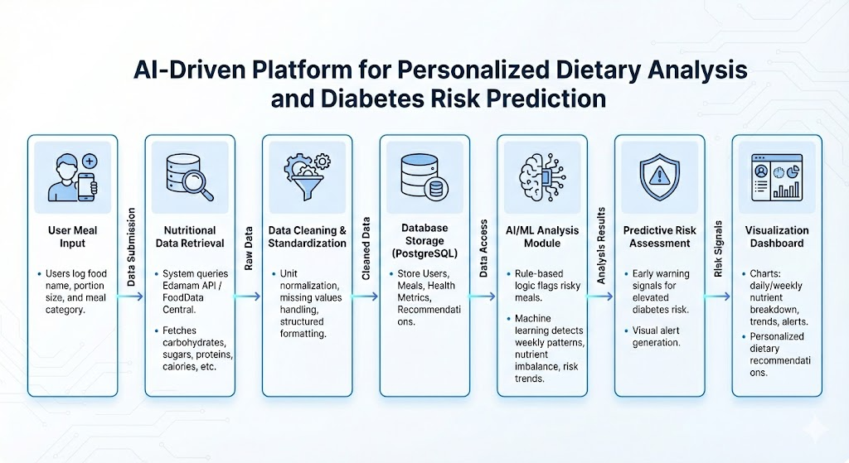

4.3 Procedures
- Week 1: Requirement study and literature review understanding diabetic dietary needs and analysing gaps in existing diet-recommendation systems.
- Weeks 2–3: Nutritional dataset collection and preprocessing gathering data from Edamam, FoodData Central, Kaggle, WHO/ICMR; cleaning and standardizing nutrient values.
- Weeks 4–5: Frontend development implementing the meal logging interface, dashboard layout, and visualization components in React.js.
- Weeks 6–7: Backend planning and API mapping defining Flask routes, database schema structure, and nutrition API integration workflows.
- Weeks 8–9: AI module foundation preparing rule-based checks, feature extraction logic, and ML-based pattern detection framework.
- Weeks 10–11: Predictive analytics and recommendation layer drafting early-risk detection logic, nutrient imbalance flags, and personalized recommendation rules.
- Week 12: Documentation and consolidation compiling methodology, system design, literature review, and biosafety considerations.

5. Project Execution

5.1 Planning and Design
- Brainstorming sessions on improving BBMP grievance mechanisms
- Decided on hybrid pipeline: Classification → Clustering → Summarization
- Designed data schema for structured complaint representation
- Drafts of routing logic and dashboard layout

5.2 Implementation
- Fine-tuned DistilBERT on labeled dataset
- Extracted embeddings with SBERT
- Clustered complaints using KMeans
- Implemented summarizer with T5
- Built interactive dashboard using Vercel + FastAPI backend
- Added text-box "live classifier" demo
- Created model server for inference

6. Tools and Techniques Used

6.1 Tools
- Python – data processing, feature engineering, and AI model development
- React.js – frontend interface for meal logging and dashboard visualization
- Flask – backend API framework for handling requests and integrating nutrition data
- PostgreSQL – relational database for storing meals, users, health metrics, and recommendations
- Edamam, FoodData Central APIs – nutritional data extraction for logged meals
- Pandas, NumPy – data cleaning, normalization, and manipulation
- scikit-learn – machine-learning components for pattern detection and trend analysis
- Matplotlib, Chart.js – dashboard visualizations for nutrient trends and analytics
- Kaggle Datasets – curated nutritional and glycaemic datasets for model refinement

6.2 Techniques
- Hybrid AI (Rule-based + Machine Learning)
- Nutritional data extraction via REST APIs
- Feature engineering for nutrient and glycaemic trend analysis
- Predictive analytics for early diabetes risk detection
- Data standardization and preprocessing
- Pattern recognition in carbohydrate and sugar intake
- Interactive visualization of dietary insights and trends

7. Partial Results

7.1 Initial Findings
- System is currently in the testing and evaluation phase.
- Frontend meal logging and dashboard interfaces are largely completed and functional.
- Nutritional API extraction produces consistent macro values in early tests.
- Rule-based checks successfully flag high-sugar and carb-heavy meals.
- Initial dataset exploration shows clear variation in glycaemic load across foods.

7.2 Iterative Improvements
- Streamlined nutrient normalization for smoother preprocessing.
- Refined rule thresholds for more accurate pattern detection.
- Expanded dataset with more region-specific food items.
- Polished dashboard visuals for better clarity during testing.

8. Prototype (Software)

8.1 Prototype Description
The current prototype of the dietary intelligence system includes:
- Meal logging interface (React.js)
- Nutritional data extraction via Edamam, FoodData Central
- Rule-based nutrient risk checker
- Interactive dashboard with nutrient trends
- Sample recommendation preview module

8.2 Development Process
- Built frontend components for logging meals and viewing charts
- Defined Flask API routes for nutritional queries
- Mapped nutritional attributes from external APIs
- Connected frontend and backend stubs for real-time data flow

8.3 Testing and Validation
- Tested nutritional extraction on a set of common food items
- Verified rule-based alerts for sugar and carbohydrate spikes
- Validated dashboard visualizations using sample datasets
- Conducted sanity checks on trend detection logic

9. Conclusion

9.1 Summary
This project demonstrates how AI can transform raw meal logs into meaningful dietary intelligence for diabetic and pre-diabetic users.
It integrates:
- Nutritional data extraction from trusted APIs
- Risk detection through rule-based and ML-driven analysis
- Pattern monitoring of sugar, carbohydrate, and macro intake
- Personalized dietary recommendations
- Dashboard-based nutrient trends and alerts
Overall, the system highlights the potential of AI in improving diabetes self-management, providing users with actionable, clinically aligned insights rather than generic calorie counts.

9.2 Personal Reflection
This project strengthened our understanding of AI-driven nutrition analysis and real-world health-tech development. We gained hands-on experience in dataset preparation, nutrient standardization, frontend implementation, and designing hybrid rule-based + ML systems. We also learned the importance of ethical data handling, biosafety considerations, and iterative refinement when working with sensitive health information. The work has shown us how AI can meaningfully support chronic disease management when applied carefully and responsibly.

10. Outcome of the Work (So Far)
- A working frontend prototype for meal logging and nutrient visualization is completed.
- Nutritional API integration and rule-based risk detection have been tested with sample data.
- Dataset collection from Kaggle, FoodData Central, and WHO/ICMR sources is underway.
- System architecture, methodology, literature review, and biosafety framework are documented.
- The project shows strong potential for future expansion into a full-scale dietary management platform and academic publication

